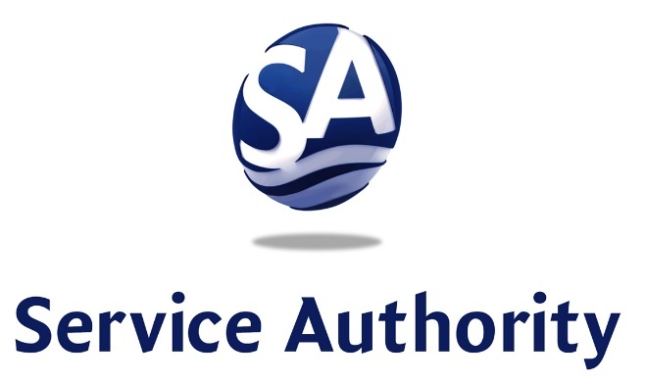
Phone (703) 335-7900
Fax (703) 335-7905 www.pwcsa.org
Prince William County Service Authority
4 County Complex Court
P. O. Box 2266
Woodbridge, VA 22195-2266

B. Paul O’Meara, Jr., Chair
Paul Colangelo, Jr., Vice Chair
Harry W. Wiggins, Secretary/Treasurer
Jim Almond, Member
Dean E. Dickey, Member
Joyce P. Eagles, Member
K. Jack Kooyoomjian, Ph.D., Member
Marlo Thomas Watson, Member

Calvin D. Farr, Jr., P.E., General Manager/CEO

PWCSA BOARD OF DIRECTORS
Meeting Agenda – January 12, 2023
6:45 PM
BOARD ROOM

1. CALL TO ORDER and GENERAL MATTERS
a) Consideration of Approval of Minutes of November 10, 2022 Meeting
b) Consideration of Announcements by Staff
c) Citizens’ Time

2. COMMENDATION/PRESENTATION
a) Commend: Paul E. Ruecker
b) Presentation: FY2023 Strategic Communications Plan

3. ACTION MATTERS
a) Approval of Agreement SA-2301 with Crown Construction Service, Inc. to Construct the Water Main Replacement Program 2 – P8 & P13 Project.
b) Authorize a Public Hearing to Consider Proposed Water and Sewer User Rates and Availability Fees.

4. GENERAL MANAGER’S REPORT

5. ATTORNEY’S TIME

6. ADMINISTRATIVE REPORTS
a) Capital Improvement Program Status Report
b) H.L. Mooney Advanced Water Reclamation Facility Operating Results
c) Monthly Financial and Operational Report

7. CONSIDERATION OF MATTERS PRESENTED BY MEMBERS

8. CLOSED MEETING

9. ADJOURNMENT

